**How to change the IP address of the Docker default bridge network:**

To change the IP address of Docker default bridge network we need to change the details of the default bridge network in this path **/etc/docker/daemon.json.**

Before doing changes in the file we need to stop the Docker service.

# systemctl stop docker.service

Now open the file, if the file not exist create the file.

# vim /etc/docker/daemon.json

"live-restore": true,

"bip": "197.168.0.1/16",

"default-address-pools": [{

"base": "197.0.0.0/8",

"size": 16

}]

}

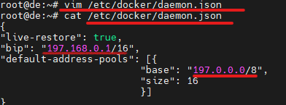

Now Restart the Docker service and List the networks

systemctl restart docker.service

# docker network ls

The output will be look like below.

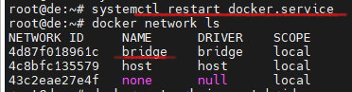

Now inspect the Docker default bridge network.

# docker network inspect bridge

See in the below picture the IP of bridge network is changed.

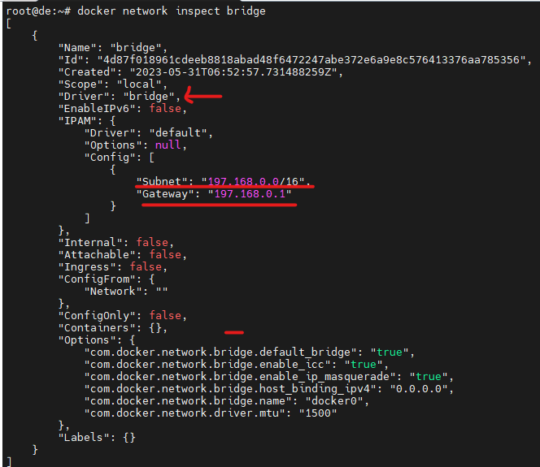

As of we know the IP address of the default bridge network is 172.17.0.0 series. Now we changed it into our desired series.